## Admin Login

### 

## 

## User Login

## 

## Add all quizid,qusid

## Quiz_competion :table

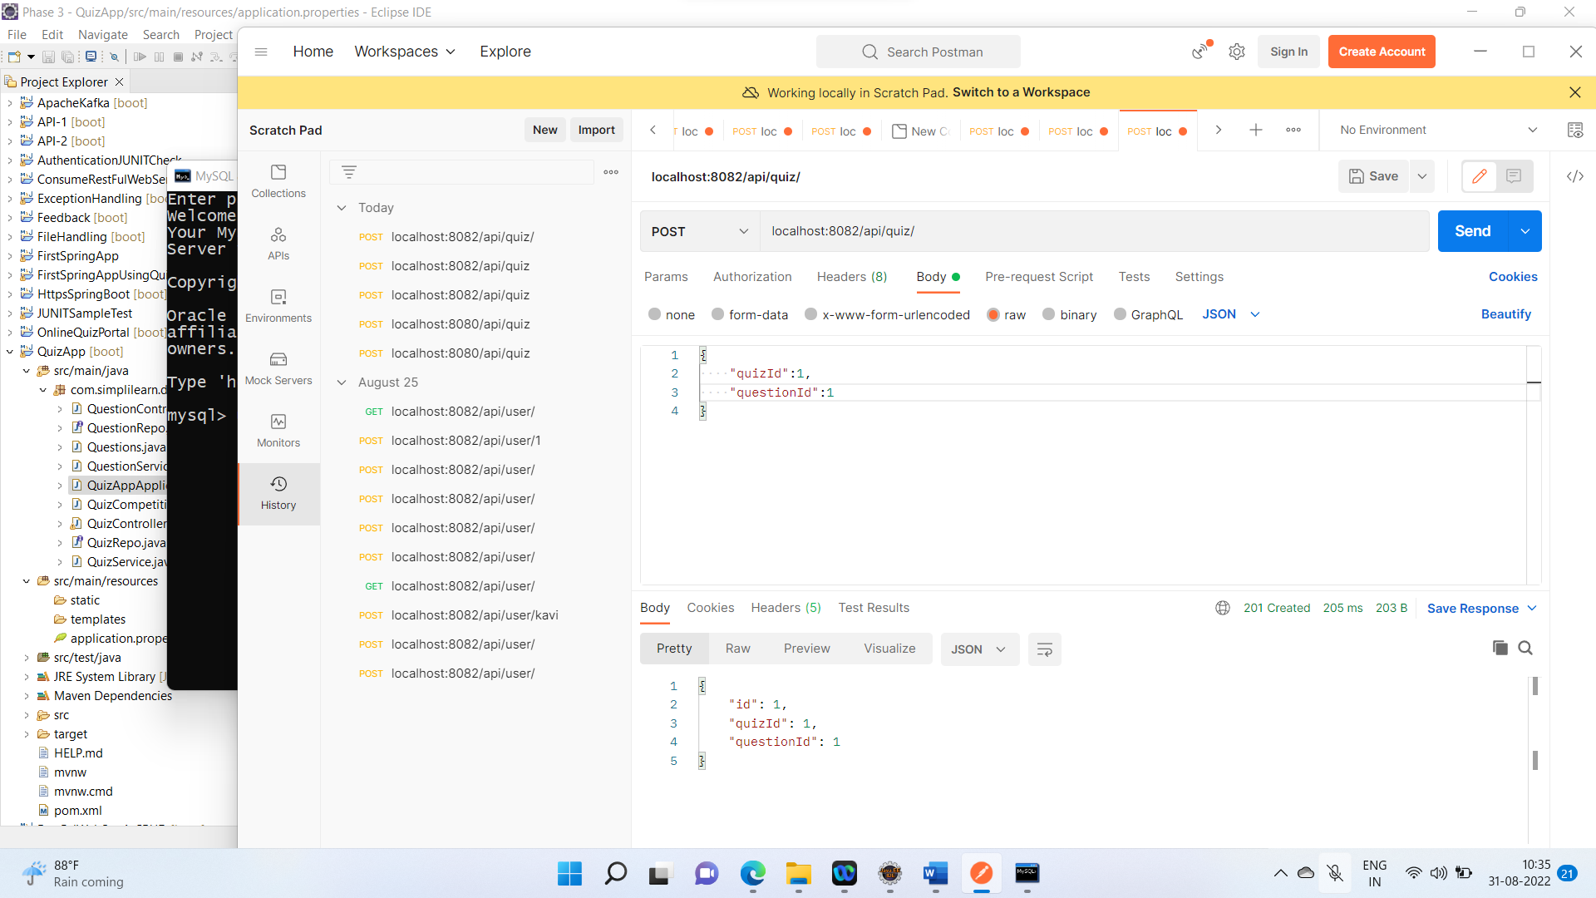

## Display All the details

## Add All User ,TableName:question

## GET All User

## Find User By id

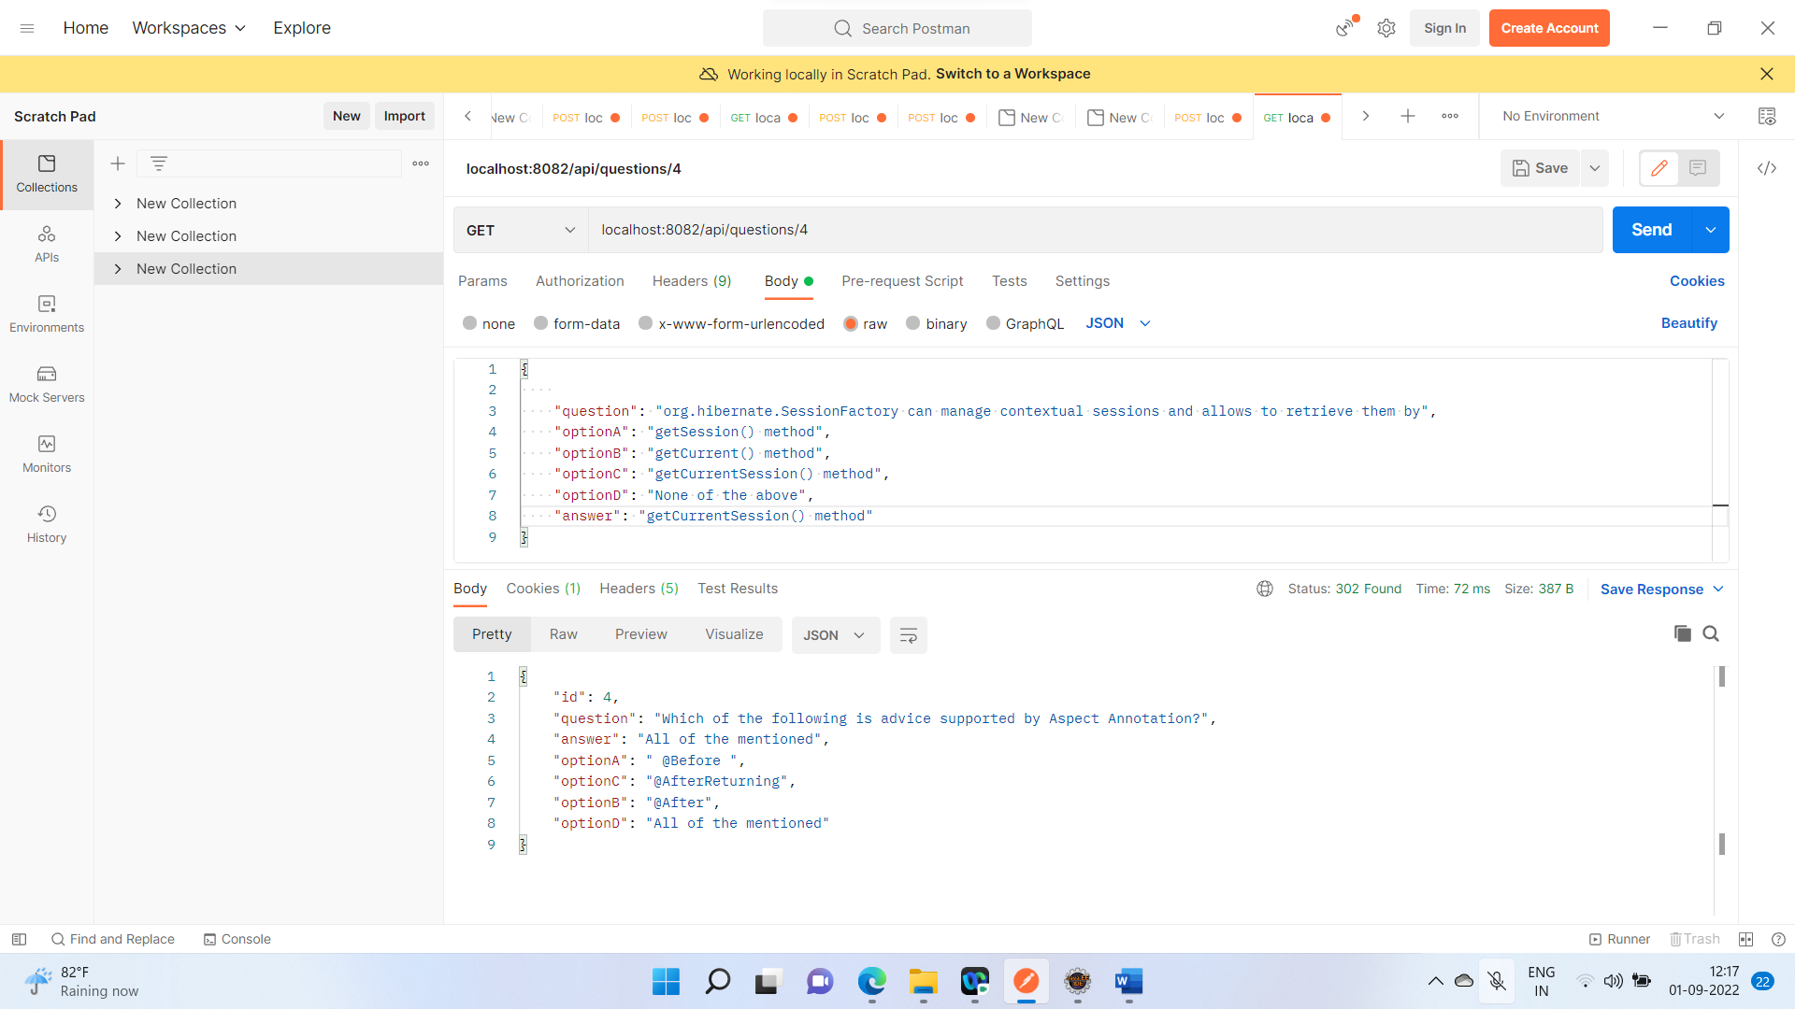

## Update the Questions By using Put method

## Here I just update the optionB for this questions

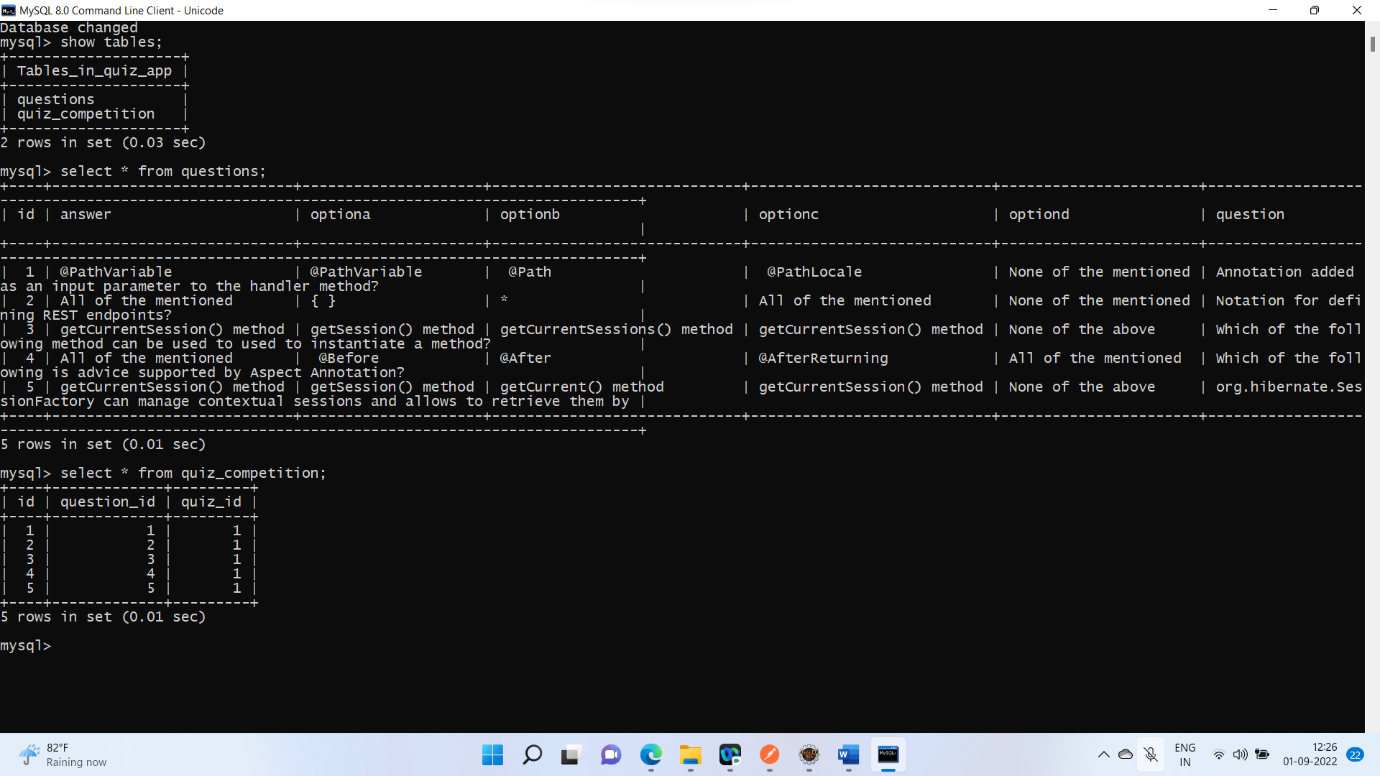

## 

## 

## 

## User Response

## 

## 

## 

## User Register

## 